## 

Assignment 1: Empathy Mapping using the Well-Architected Framework

As a Cloud Architect, your task is to apply the Well-Architected Framework to an e-commerce company's Empathy Map for understanding internal and external personas. The Empathy Map is a tool that helps organizations understand their customers by identifying what they think, feel, see, hear, say, and do. By understanding the customer's perspective, companies can design better products and services that meet their needs.

To complete this assignment, follow these steps:

Step 1: Familiarize yourself with the e-commerce company's Empathy Map.

Review the Empathy Map and identify the different internal and external personas for the e-commerce company. Internal personas include employees, stakeholders, and decision-makers within the organization, while external personas include customers, partners, suppliers, and other stakeholders outside the organization.

Step 2: Map the Empathy Map to the Well-Architected Framework.

Using the Well-Architected Framework, identify the different components that are relevant to the Empathy Map. For example, the Operational Excellence pillar may be relevant to internal personas who need to collaborate effectively to deliver products and services, while the Security pillar may be relevant to external personas who require a secure and trustworthy e-commerce platform.

Step 3: Identify gaps and areas for improvement.

Using the Well-Architected Framework, identify areas where the e-commerce company's Empathy Map may have gaps or areas for improvement. For example, the Empathy Map may not adequately address the needs of external personas who are concerned about data privacy and security.

Step 4: Develop recommendations for improvement.

Based on the gaps and areas for improvement identified in Step 3, develop recommendations for how the e-commerce company can improve their Empathy Map using the Well-Architected Framework. For example, the company may need to enhance their security measures to meet the needs of external personas concerned about data privacy.

Step 5: Present your findings and recommendations.

Create a presentation that summarizes your findings and recommendations, and present it to the relevant stakeholders within the e-commerce company. Be sure to explain the benefits of using the Well-Architected Framework for Empathy Mapping, and how it can help the company design better products and services that meet the needs of their customers.

# Questions:

1. Who are the key stakeholders involved in the e-commerce company?
2. What are their primary roles and responsibilities?
3. What motivates them in their roles?
4. **What are their pain points and challenges?**
5. How do they currently interact with the e-commerce platform?
6. What are their expectations for the platform?
7. How do they prefer to receive information and communicate?
8. What is the customer journey through the e-commerce platform?
9. What are the touchpoints between the customer and the platform?
10. How does the customer interact with the platform?
11. **What are the customer pain points and challenges?**
12. **What are the customer expectations for the platform?**
13. **How can the platform improve the customer experience?**
14. What are the commonalities between the internal and external personas?
15. What are the differences between the internal and external personas?
16. How can the platform address the needs of both internal and external personas?

## Checklist:

1. Identify key stakeholders
2. Define roles and responsibilities
3. Identify motivations
4. Identify pain points and challenges
5. Define current interactions with the platform
6. Define expectations for the platform
7. Define preferred methods of communication
8. Map the customer journey through the platform
9. Identify customer touchpoints with the platform
10. Define customer pain points and challenges
11. Define customer expectations for the platform
12. Identify areas for platform improvement
13. Identify commonalities and differences between internal and external personas
14. Develop strategies to address the needs of both internal and external personas.

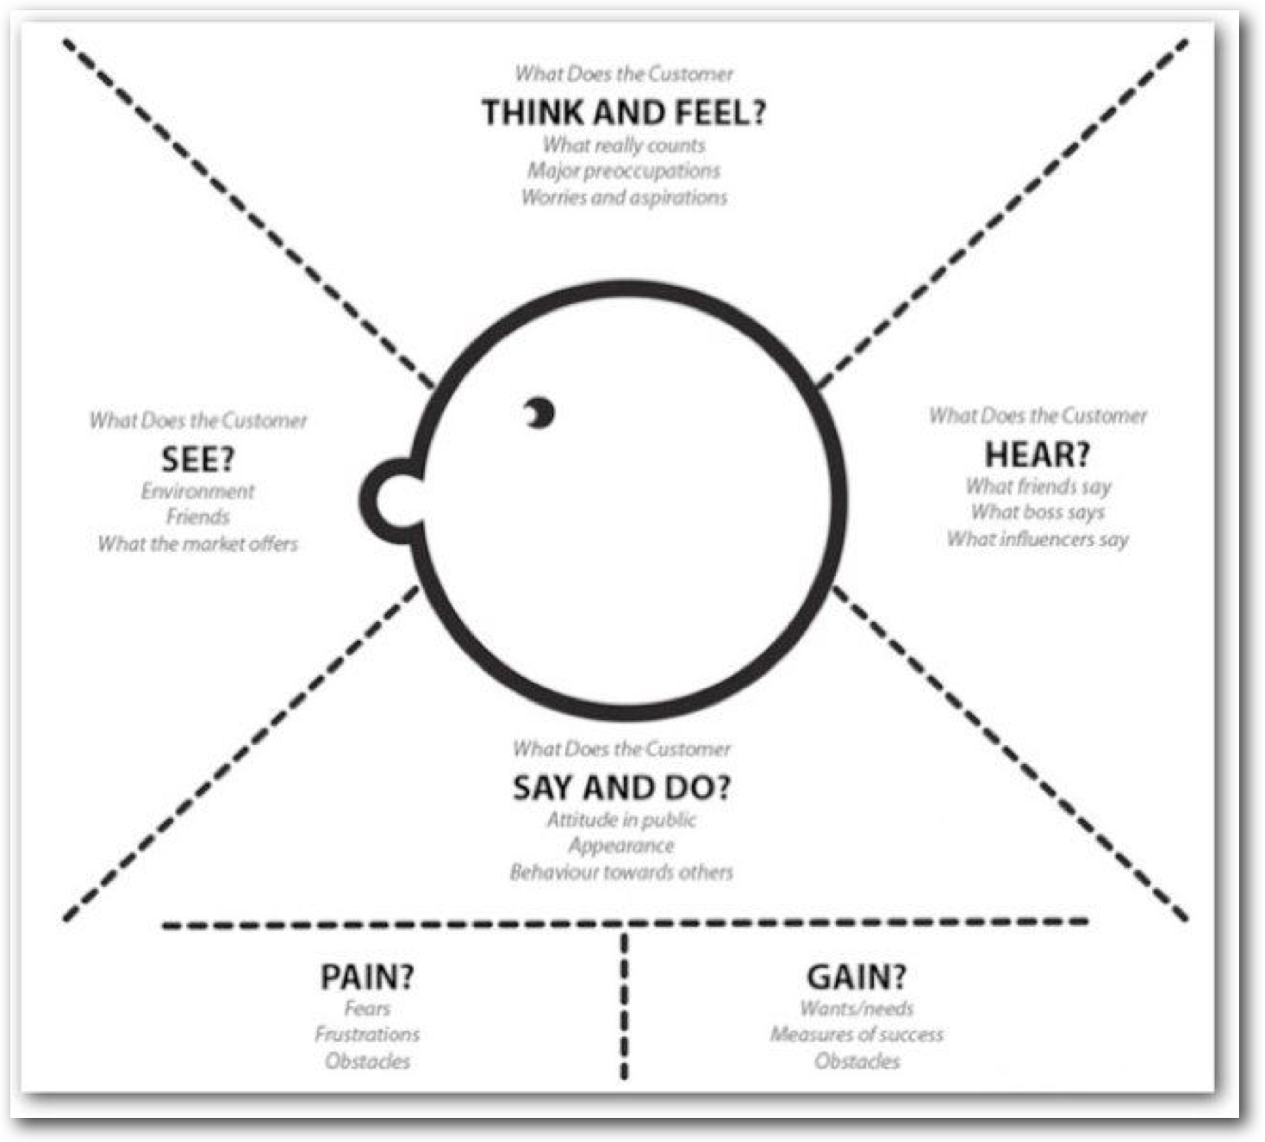

# Solution:

## Empathy Map for B2B Customer Persona:

1. Say: What are the main pain points for B2B customers in terms of product availability, pricing, and customer support? How can we address these pain points to improve their experience?
2. Think: What motivates B2B customers to purchase our products? How can we leverage this knowledge to tailor our offerings and messaging to better serve them?
3. Do: How do B2B customers typically interact with our website and sales team? Are there areas where we can streamline their experience or improve communication?
4. Feel: What emotions are B2B customers experiencing when they engage with our brand? How can we create a more positive emotional connection to our products and services?

## Empathy Map for B2C Customer Persona:

1. Say: What are the main pain points for B2C customers in terms of product availability, pricing, and customer support? How can we address these pain points to improve their experience?
2. Think: What motivates B2C customers to purchase our products? How can we leverage this knowledge to tailor our offerings and messaging to better serve them?
3. Do: How do B2C customers typically interact with our website and customer support team? Are there areas where we can improve their experience or better meet their needs?
4. Feel: What emotions are B2C customers experiencing when they engage with our brand? How can we create a more positive emotional connection to our products and services?

## Empathy Map for B2B2C Customer Persona:

1. Say: What are the main pain points for B2B2C customers in terms of product availability, pricing, and customer support? How can we address these pain points to improve their experience?
2. Think: What motivates B2B2C customers to purchase our products? How can we leverage this knowledge to tailor our offerings and messaging to better serve them?
3. Do: How do B2B2C customers typically interact with our website, sales team, and customer support? Are there areas where we can streamline their experience or improve communication?
4. Feel: What emotions are B2B2C customers experiencing when they engage with our brand? How can we create a more positive emotional connection to our products and services?

## Checklist:

1. Identify key customer personas for the e-commerce company, including B2B, B2C, and B2B2C.
2. Develop empathy maps for each customer persona, taking into account their pain points, motivations, typical interactions, and emotions.
3. Use the insights gained from the empathy maps to inform the design and development of the e-commerce platform, including product offerings, messaging, user experience, and customer support.
4. Continuously evaluate and refine the empathy maps and the e-commerce platform based on customer feedback and evolving market trends.

## Personas:

1. Customer Persona - This persona represents the typical end-user of the e-commerce platform. They are interested in finding and purchasing products quickly and easily.
2. Retailer Persona - This persona represents the sellers who use the e-commerce platform to sell their products to end-users. They are interested in having an easy-to-use platform that allows them to manage their **inventory, track orders, and communicate with customers**.
3. Marketing Persona - This persona represents the individuals responsible for promoting the e-commerce platform and increasing its visibility to potential customers. They are interested in having access to data and analytics to help them make informed decisions about marketing strategies.
4. IT Persona - This persona represents the individuals responsible for managing the technical aspects of the e-commerce platform, **including system integrations, data security,** and website performance. They are interested in ensuring the platform is stable, secure, and scalable.
5. Customer Service Persona - This persona represents the individuals responsible for providing support to customers who have questions or issues related to the e-commerce platform. They are interested in having access to customer data and order information to quickly resolve customer issues.

## Empathy Map

To create the empathy map, you can follow these steps:

* Identify the key stakeholders and users of the e-commerce platform, both internal and external. This can include customers, employees, partners, vendors, and other stakeholders.
* For each persona, ask the following questions:
  + **What are their goals and objectives?**
  + **What are their pain points and challenges?**
  + **What are their needs and expectations?**
  + **What are their preferences and behaviors?**
  + **What are their demographics and psychographics?**
* Use the answers to these questions to fill out the empathy map for each persona, which should include the following sections:
  + What they see: What are the external factors that influence their perceptions?
  + What they hear: What do they hear from others or the media?
  + What they think and feel: What are their attitudes, beliefs, and emotions?
  + What they say and do: What are their actions, behaviors, and communication styles?
  + Pain points: What are their frustrations, problems, or obstacles?
  + Needs: What are their requirements, desires, or expectations?
  + Insights: What are the key takeaways and opportunities to improve their experience?
* Use the empathy maps to inform your design decisions and prioritize the features and capabilities that address the most important needs and pain points of the personas.

Checklist for Empathy Map for Understanding Internal and External Personas:

* Identify the key stakeholders and users of the e-commerce platform, both internal and external.
* Ask the questions to understand the goals, pain points, needs, preferences, demographics, and psychographics of each persona.
* Fill out the empathy map for each persona, including what they see, hear, think and feel, say and do, pain points, needs, and insights.
* Use the empathy maps to inform your design decisions and prioritize the features and capabilities that address the most important needs and pain points of the personas.